
Reggio Emilia Study Week 2013


Application form

Event details and description
Reggio Emilia International Study Group
Sunday 14th to Friday 19th April 2013
Loris Malaguzzi International Centre, Reggio Emilia, Italy.

A one week study visit to learn about and be inspired by the world renowned educational approach of the preschools and infant toddler centres of Reggio Emilia.

This week long course will explore the key principles underpinning the Reggio approach to early childhood education including:
- History and background
- Creativity and expressive languages of children
- Listening to children
- The environment as the third teacher
- Parents as partners
- Democratic citizenship
- Children as a subject of rights
- Children and educators as researchers
- Observation, interpretation, documentation
- Making learning visible
- Professional dialogue
The course content will be delivered through:
- Lectures
- Presentations
- Discussion groups
- Exhibitions
- Visits to preschools and infant toddler centres
- Workshops

Participants
We welcome applications from anyone working in the field of early childhood education and wanting to learn about the Reggio approach.
There will be delegates from other English speaking countries in attendance. (Australia, New Zealand, America, Singapore etc)

We encourage participation of pairs, teams or groups but applications must be filled out for each individual.
Applications will be considered on a first come first served basis.
Applicants will be contacted via email within 10 days of receipt of signed application form.

Participation Fee
The participation fee is £1,350. This fee covers:
- Administration, advice and support
- Seminars, presentations, exhibits, visits to preschools.
- Bus transportation to schools (as necessary)
- Guided tour of the city
- UK only discussion groups
- Interpreters
- ReFocus Network membership

Please note: The fee does not include flights and accommodation.
In the event of a significant change in the exchange rate at time of final payment, we may need to invoice delegates for the disparity.

Travel arrangements
Participants will need to make their own travel arrangements. We recommend you fly to Bologna Airport as this is the most convenient. We can arrange bus transfers from Bologna to Reggio Emilia. It is also possible to travel to Milan or Parma and travel from here by train to Reggio Emilia (we do not arrange transfares from Parma or Milan)
We advise that you are in Reggio Emilia by Sunday 14th April 2013 and return after Friday 19th April (6pm finish) 2013. We intend to have a UK group welcome meeting on the Sunday morning. In the afternoon there is normally a guided tour around the town.
Accommodation
Sightlines Initiative is happy to arrange accommodation for you and organises block bookings with reputable hotels in Reggio Emilia. 7 nights hotel accommodation will cost in the region of £550. The cost is reduced by sharing a room.
Venue
The event will take place at the purpose built Loris Malaguzzi International centre on the outskirts of Reggio Emilia. This centre is within walking distance of the hotels.

Reggio Emilia Study Week 2013

Reggio Emilia International Study Group
Sunday 14th to Friday 19th April 2013
Loris Malaguzzi International Centre, Reggio Emilia, Italy.

Filling in the application form.
- Step 1: Fill in the form below.
- Step 2: Print, sign, date and send form to Margaret Harding.
(Please note we require a signed copy of the form before we can process your application)
- Step 3: Email copy of application to Margaret@sightlines-initiative.com
Please fill in all required fields marked by an *.
Application form

Title*
Forename*
Surname*
Job Title*
Telephone* Fax
Work Address *
City / Town*
County*
Country*
Postcode*

Email* Please type and then confirm your email address carefully as it will be used for all correspondence.
Confirm Email*

Invoice Details
If your invoice details are different from above please enter them below.
Invoicing contact name and address

Professional Outline
Please provide a professional outline of yourself. This text will be included in a Participants Booklet by way of introduction to other participants. (Maximum 150 words please)

Professional Outline

Consent

I consent to my details being included in the participants’ information booklet. (If you want to exclude or change any of your contact details from this booklet please specify changes/exclusions here)

Study Visits

How/where did you hear about the Study week?
Why do you want to attend a study week? (max 150 words)
Have you previously visited the Reggio's preschools? If so name year/s

Reggio Emilia Study Week 2013

Terms and Procedures
- Your application will be processed when we receive your signed form.
- Closing date for signed application forms is 29th March 2013. Late applicants should contact Sightlines Initiative directly to enquire of places.
- Cancellations made between 4th February and 25th February 2013 will be subject to 15% of the £1350 fee.
- Cancellations made on/after 25th February 2013 will be subject to 60% of the £1350 fee.
- Cancellations made after 15th March 2013 will be subject to 100% of the £1350 fee.
- All conference fees are payable three weeks from invoice date and by 4th March 2013 at the latest. Late payments received without prior agreement after this date will incur a 5% administration charge.
SIGNATURE AND DATE
………………………………………………………………
Please print and sign a copy of your completed application form and send or fax to:
Margaret Harding, Sightlines Initiative, 20 Great North Road, Newcastle upon Tyne.NE2 4PS.
Phone 0191 261 7666
Please also email a copy of this form to margaret@sightlines-initiative.com
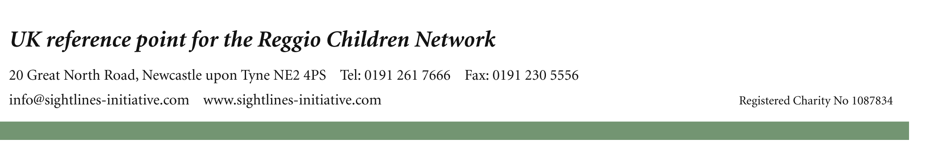
Applicants will be contacted via email within 10 days of receipt of signed application form.

